AWS KMS
AWS KMS (Key Management Service) is a fully managed encryption service provided by Amazon Web Services that allows users to create, manage, and control cryptographic keys used to secure data. It integrates with multiple AWS services and helps protect sensitive information by enabling encryption, decryption, and access control.
USE CASE :
A company stores customer financial documents in an S3 bucket. To ensure sensitive customer data is protected, the organization uses AWS KMS to encrypt files before storing them in S3. Only authorized IAM users and applications are allowed to decrypt and access the files.
Create KMS Key
Click on create key Key Type: Symmetric Key Usage: Encrypt and Decrypt Alias Click Create Key
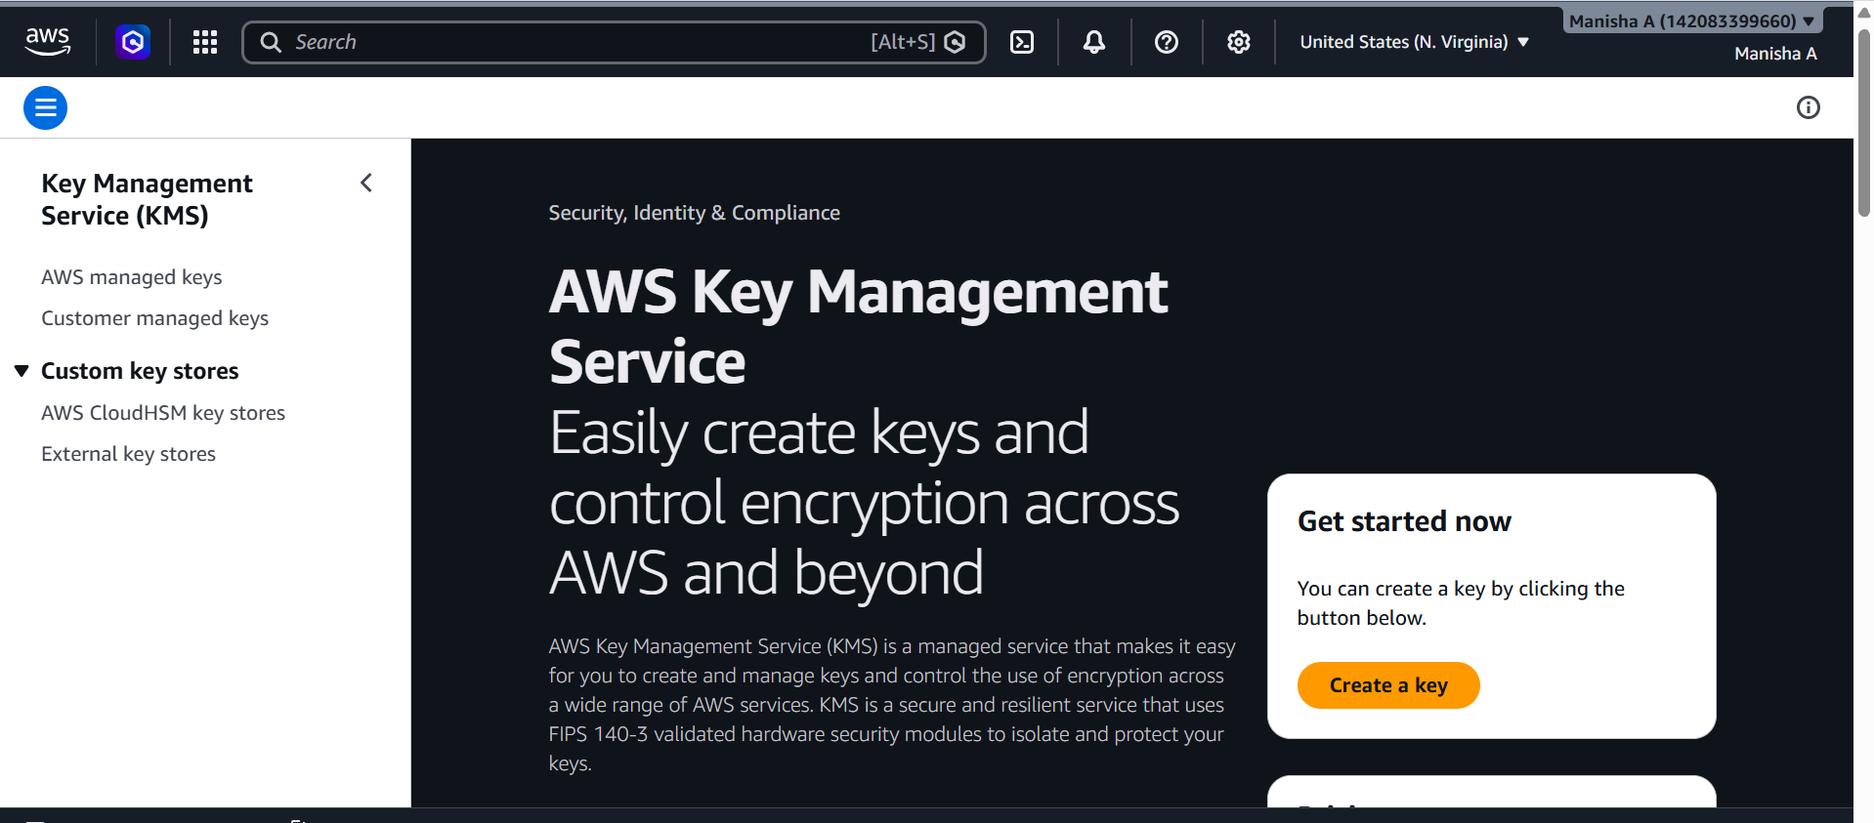
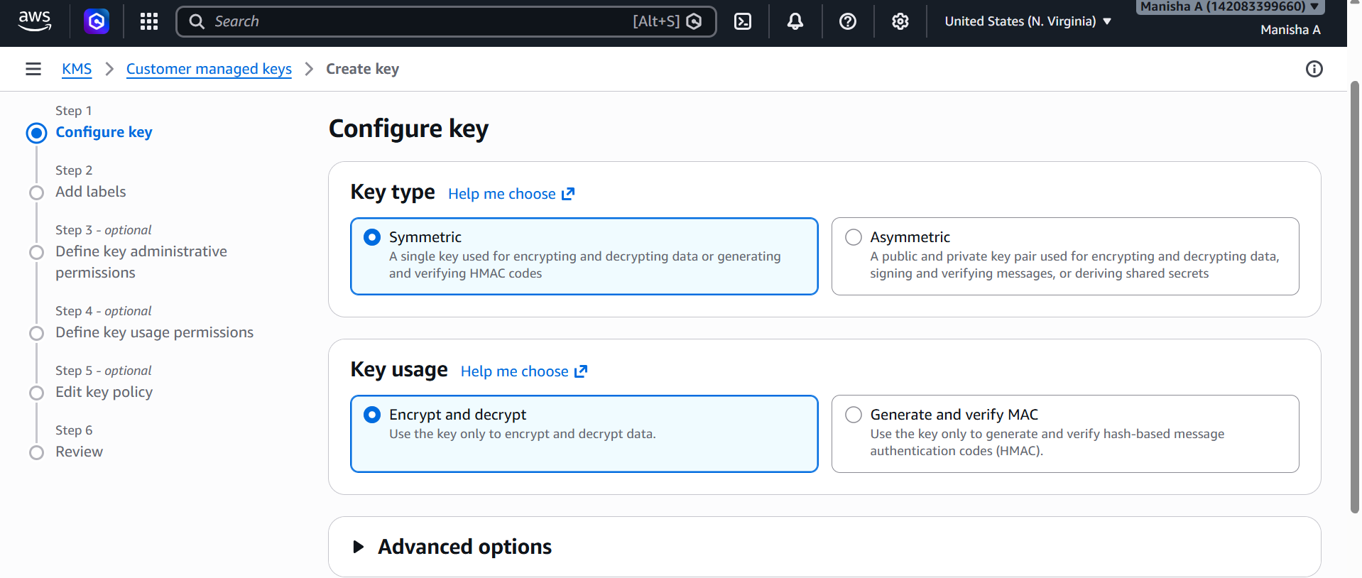
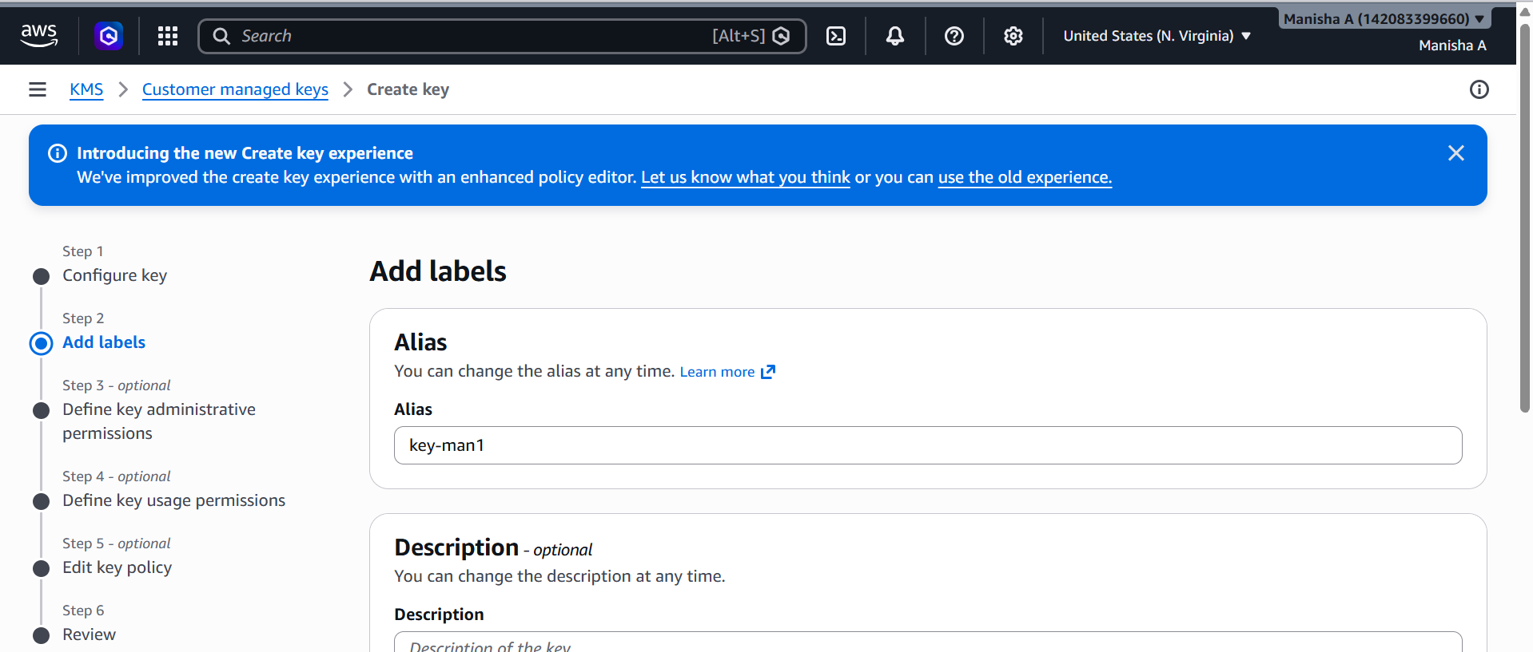
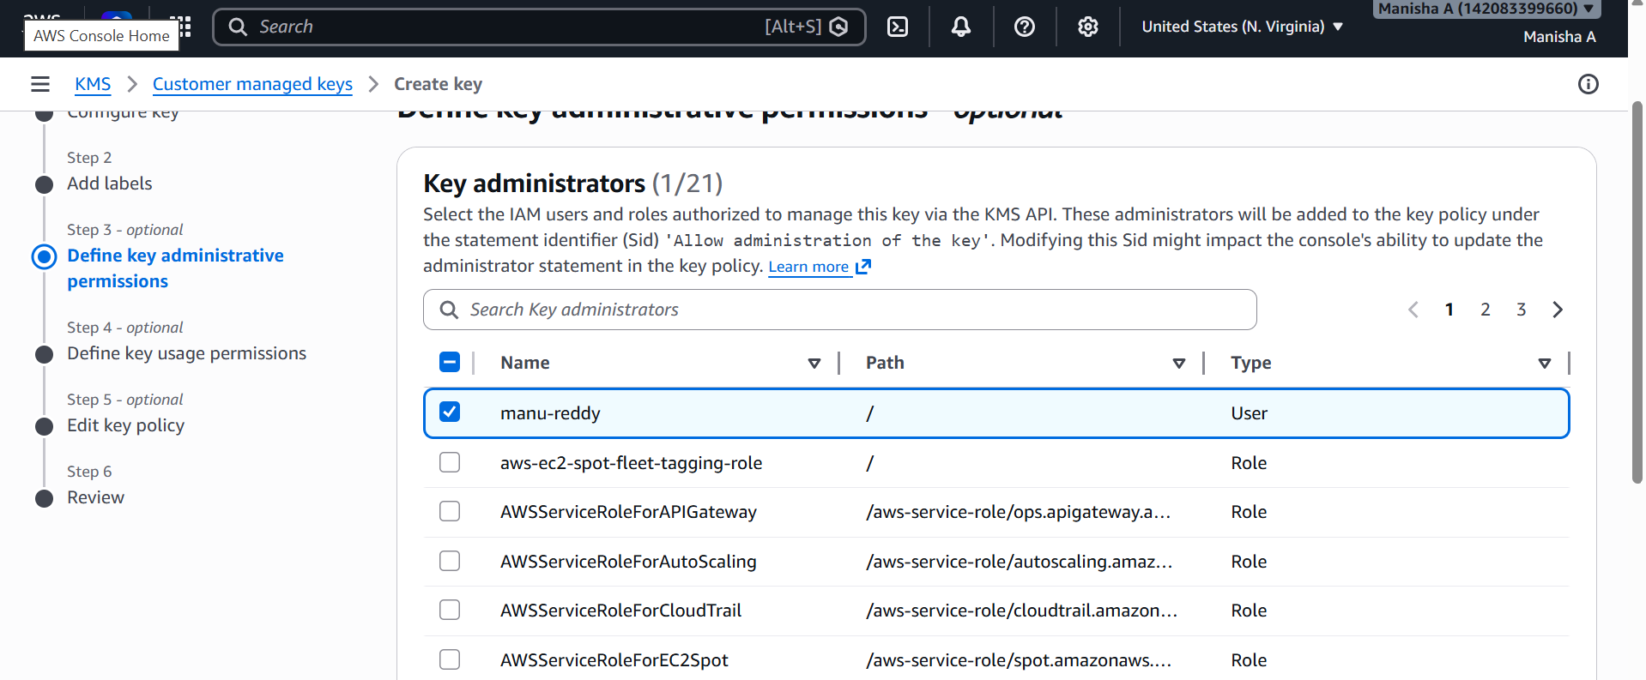
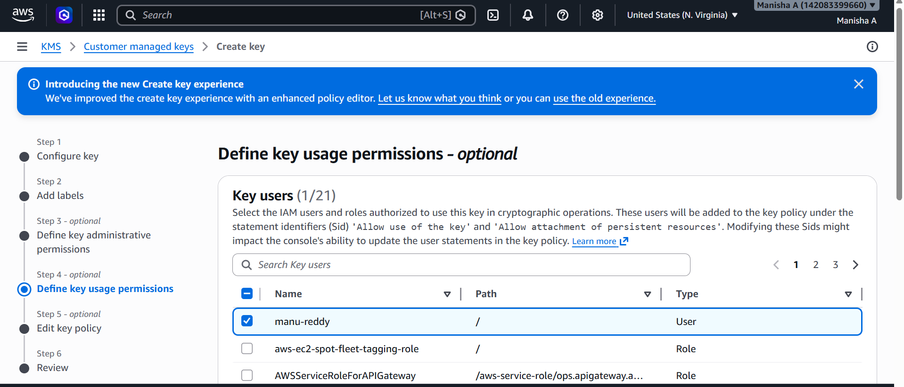
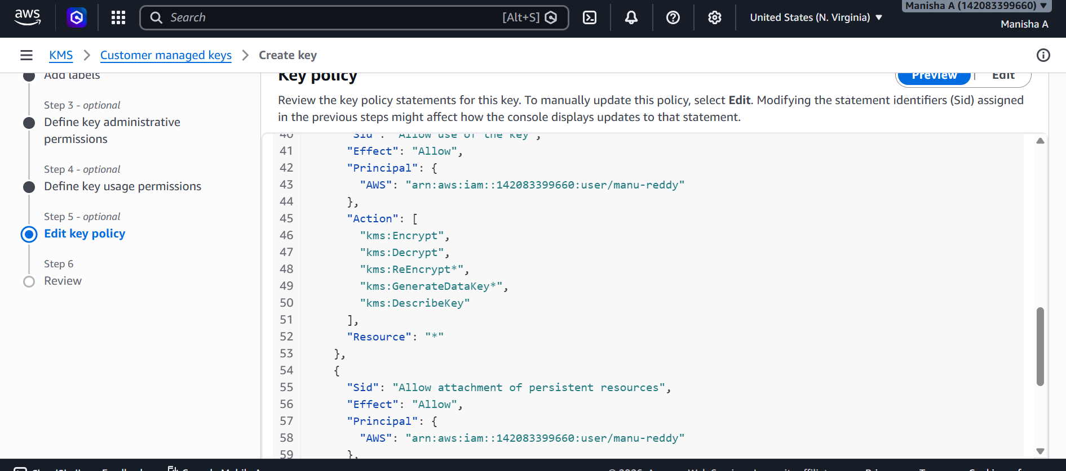
Create S3 bucket
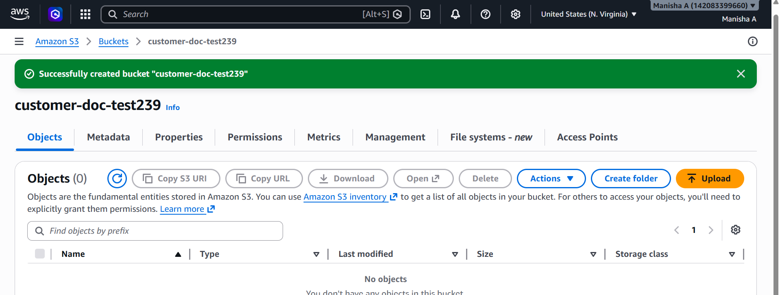
Enable KMS Encryption on S3 Bucket
Go to Property Scroll to default encryption click edit enable server-side encryption choose aws kms select KMS key save changes
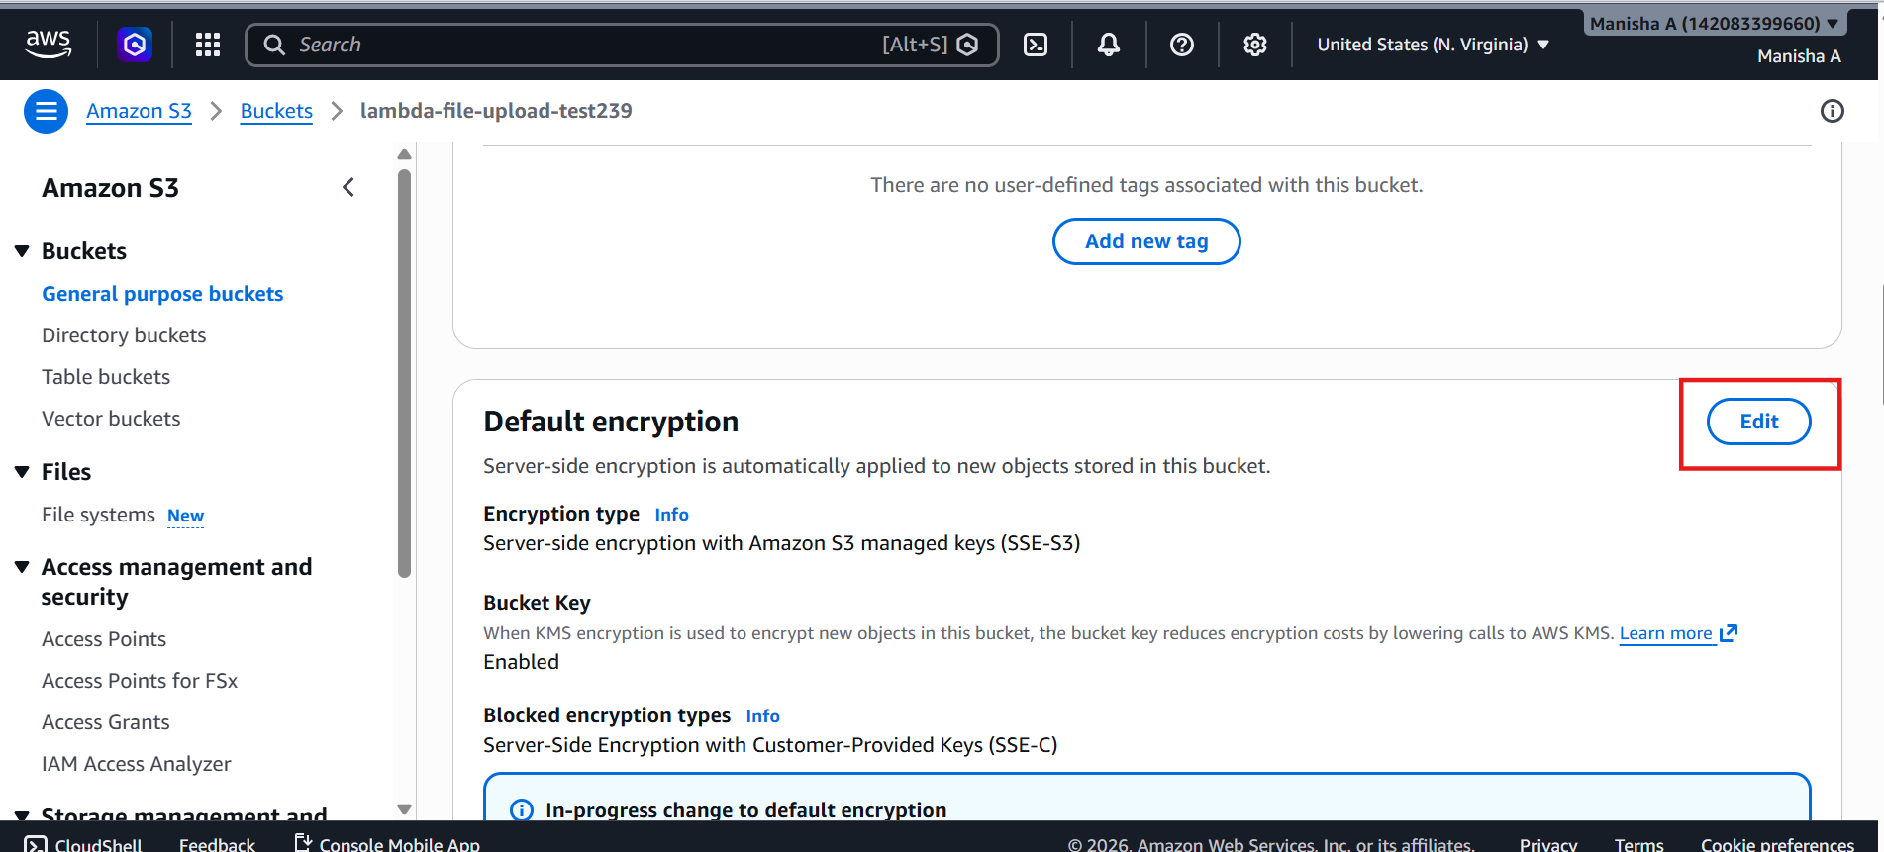
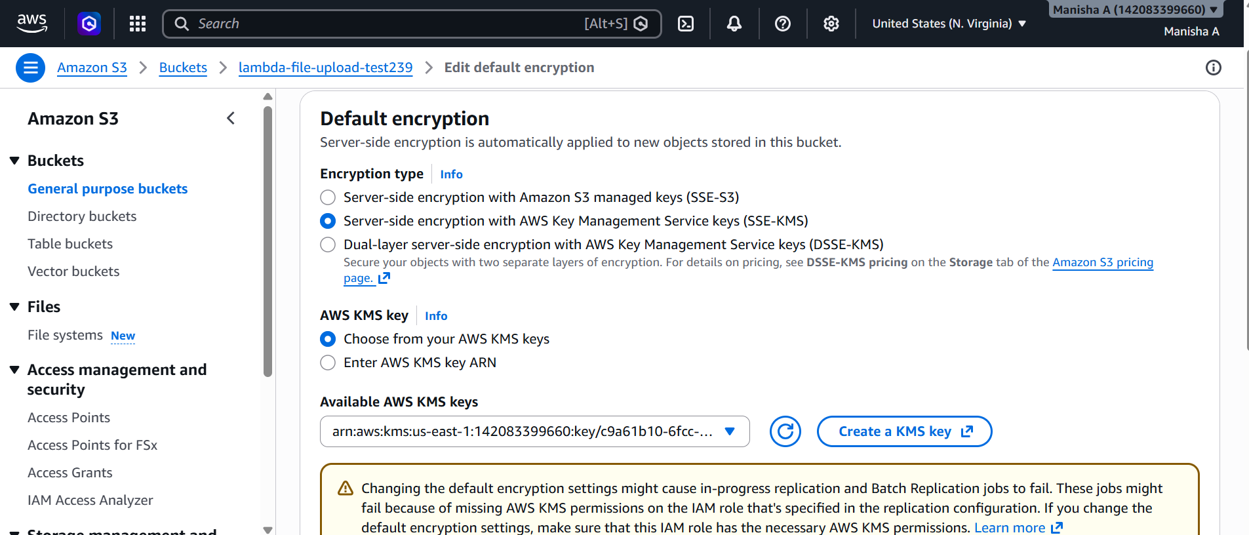
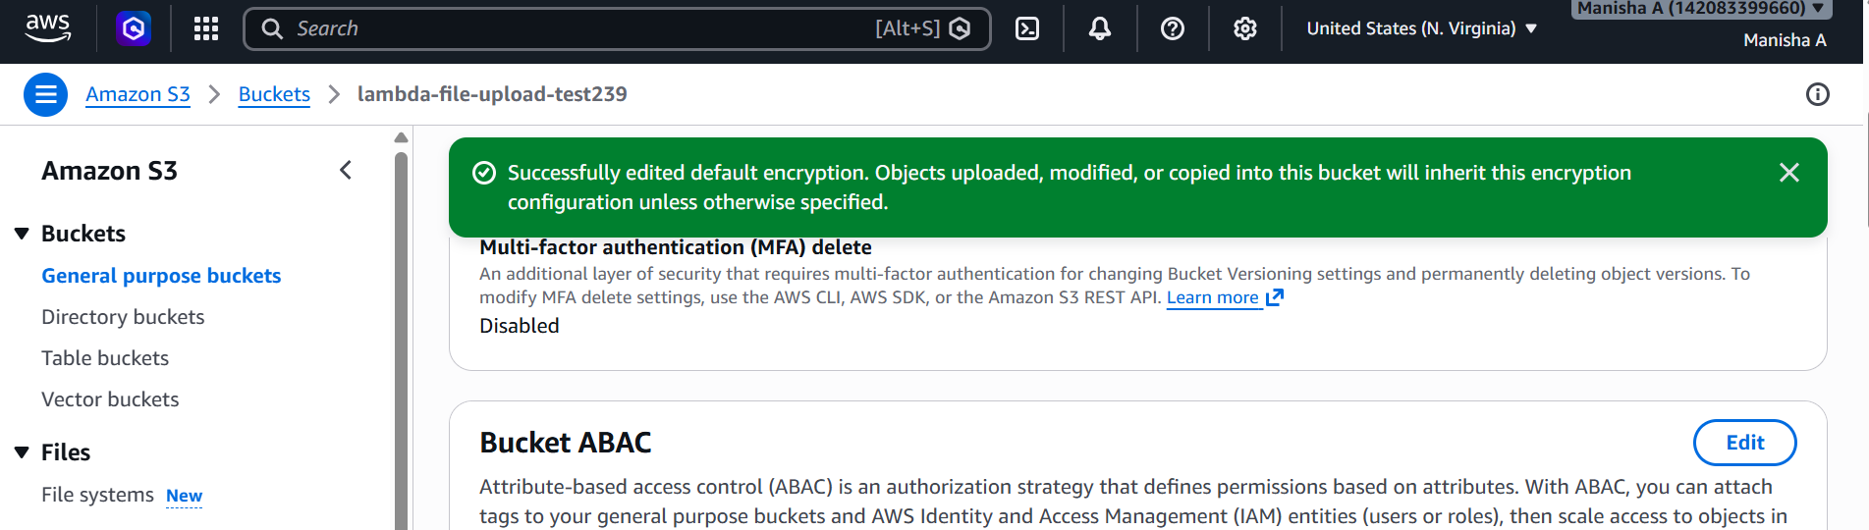
Upload a doc in s3 bucket
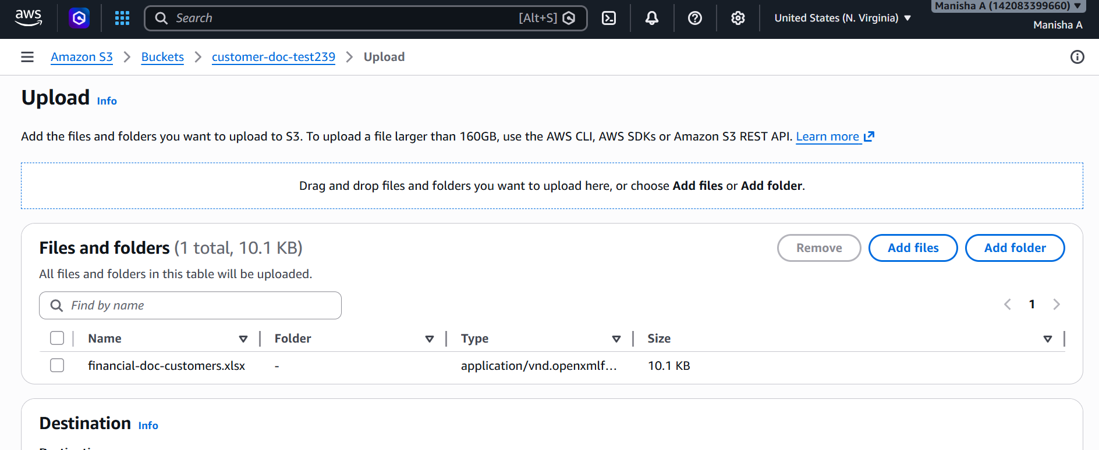
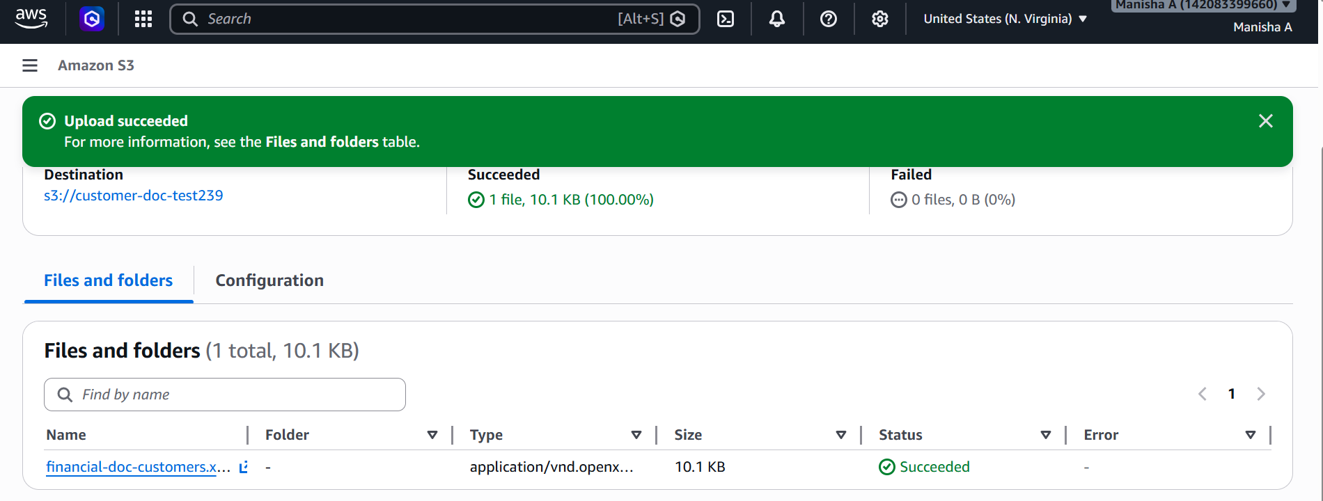
To verify
Go to s3 object properties we can see encryption key ARN
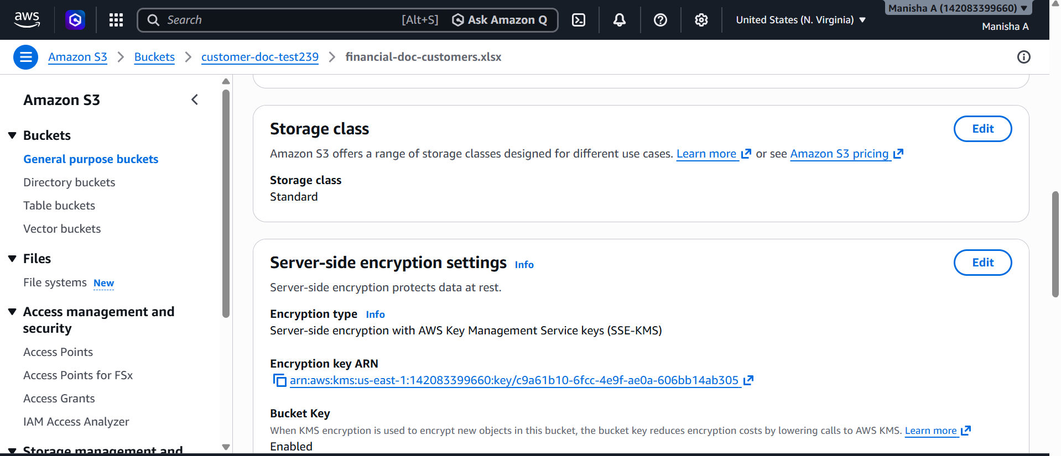
I have removed key access for the user and tried to download the object but unable to download though the user has full s3 access
